**CS4004: Software Testing**

**And Inspection Autumn 2018**

*Conor Nolan (17234329)*

*James Brosnan (17241448)*

*Thomas Langley (17215145)*

*Ross Duffy (1720162*4)

**Table of Contents**

1. Cover Page
2. Table of Contents
3. Task #1: Bug Reporting

3.1 Bug Report 1: Only one administrator is allowed on the system at a time.

3.2 Bug Report 2: Administrator cannot delete an account from the system

3.3 Bug Report 3: No check for identical student accounts being created by supervisor

3.4 Bug Report 4: Student cannot reset password

3.5 Bug Report 5: View supervisors Quicklinks error

* 1. Bug Report 6: View topics Quicklinks error

1. Task #2: Test-Driven Development using JUnit

4.1 Test #1: Testing a Calculator class using the Default Fail Case in JUnit.

* + 4.1.1 Code developed for the test.
  + 4.1.2 Code developed for the program.
  + 4.1.3 Screenshot of failure.

4.2 Test #2: Testing a Calculator class using test code developed by the group.

* + 4.2.1 Code developed for the test.
  + 4.2.2 Code developed for the program.
  + 4.2.3 Screenshots of success and failure.

**Task #1: Bug Reporting**

|  |
| --- |
| **Log of Tasks Done:**  Read requirements documentation – 03/10/2018  Wrote up 6 bug reports on Bugzilla – 12/11/2018 to 16/11/2018  Took screenshots of the bug reports – 16/11/2018  Formulated document – 19/11/2018 to 21/11/2018 |
| **Reflection:**  We arranged a group meeting and decided to communicate via a WhatsApp group. Each member was given their own specific task and the work was distributed evenly. The work was divided between us as follows:   * Conor: Bug Report 1 * Thomas: Bug Reports 2 and 3 * James: Bug Report 4 * Ross: Bug Reports 5 and 6   We read the requirements documentation and from this we formulated our bug reports.  We met regularly to assist one another and track our progress. By carrying out these tasks, we learned a lot about the usefulness of Bugzilla for tracking bugs and we can appreciate how it helps software engineers fix those issues. |
| **What is being submitted to show what has been learned:**  3.1 Bug Report 1: Only one administrator is allowed on the system at any one time  3.2 Bug Report 2: Administrator cannot delete an account from the system  3.3 Bug Report 3: No check for identical student accounts being created by supervisor  3.4 Bug Report 4: Student cannot reset password  3.5 Bug Report 5: View supervisors Quicklinks error  3.6 Bug Report 6: View topics Quicklinks error |

**3.1 Bug Report 1 - Only one administrator is allowed on the system at any one time**

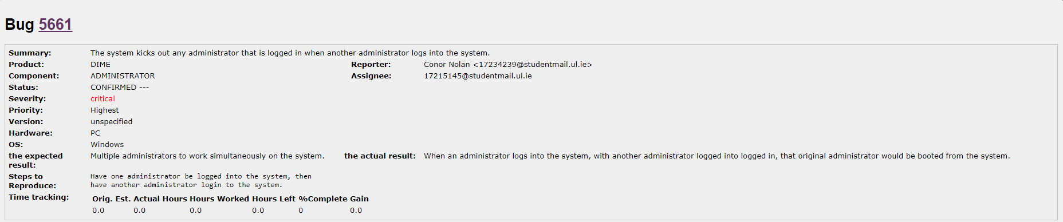

Screenshot of Bug Report 1

**3.2 Bug Report 2: Administrator cannot delete an account from the system**

Screenshot of Bug Report 2

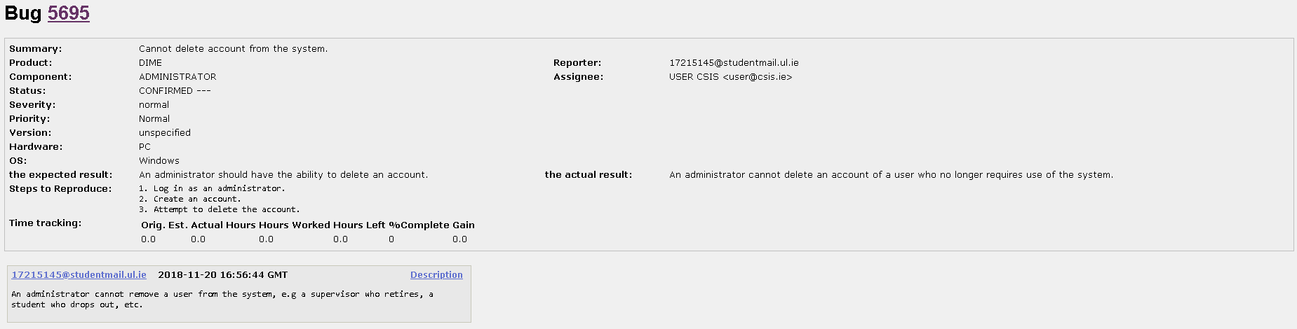

**3.3 Bug Report 3: No check for identical student accounts being created by supervisor**

Screenshot of Bug Report 3

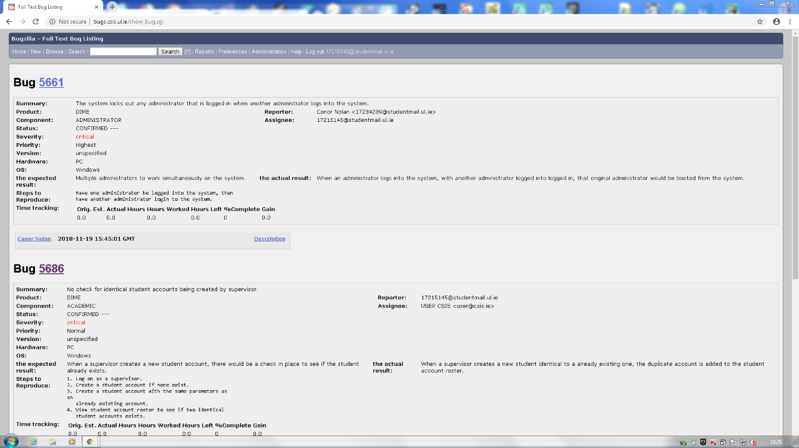

**3.4 Bug Report 4: Student cannot reset password**

Screenshot of Bug Report 4

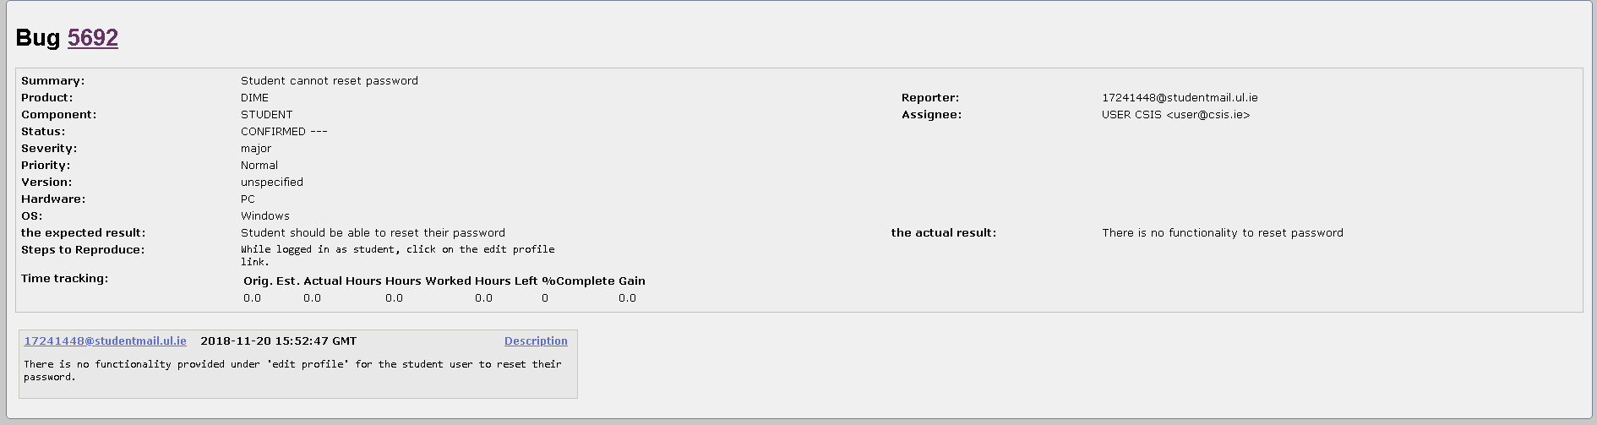

**3.5 Bug Report 5: View supervisors Quicklinks error**

Screenshot of Bug Report 5

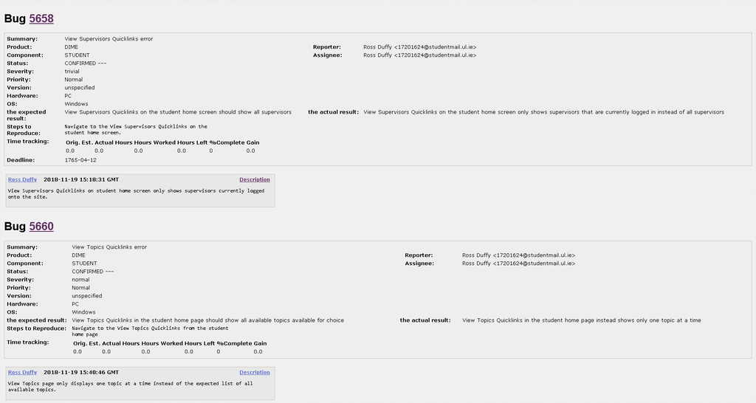

**3.6 Bug Report 6: View topics Quicklinks error**

Screenshot of Bug Report 6



**4.Task #2: Test-Driven Development using jUnit**

|  |
| --- |
| **Log of Tasks Done:**  Wrote test code consisting of 5 methods – 9/11/2018  Configured JUnit on Eclipse – 12/11/2018  Created a JUnit test class – 12/11/2018  Created test cases and then added to them – 12/11/2018 – 15/11/2018  Took screenshots of success/failure – 16/11/2018  Formulated document – 19/11/2018 - 21/11/2018 |
| **Reflection:**  In accomplishing this task we decided to have another group meeting where we decided on who would be given what tasks. Also we continued using our WhatsApp group for communication. The tasks required on JUnit were divided between us as follows:   * Ross: Set up JUnit in Eclipse and set up the first test. * Conor: Ran the first test, and take screenshots of the first test’s program code, test code, and outcome. * James: Set up the second test. * Thomas: Take screenshots of the second test’s program code, test code, and outcome.   In doing this task we had our first practical experience of software testing. We learned how to use JUnit and write test cases. |
| **What is being submitted to show what has been learned:**  4.1 Test #1: Testing a Calculator class using the Default Fail Case in JUnit.   * + 4.1.1 Code developed for the test.   + 4.1.2 Code developed for the program.   + 4.1.3 Screenshot of failure.   4.2 Test #2: Testing a Calculator class using test code developed by the group.   * + 4.2.1 Code developed for the test.   + 4.2.2 Code developed for the program.   + 4.2.3 Screenshots of success and failure. |

4.1 Test #1: Testing a Calculator class using the Default Fail Case in JUnit.

When JUnit was set up in Eclipse, the initial test case was tested. This was designed and expected to fail, but it gave us an introduction to how JUnit operates, and gave us a foundation to start our test-driven development.

4.1.1 Code developed for the test.

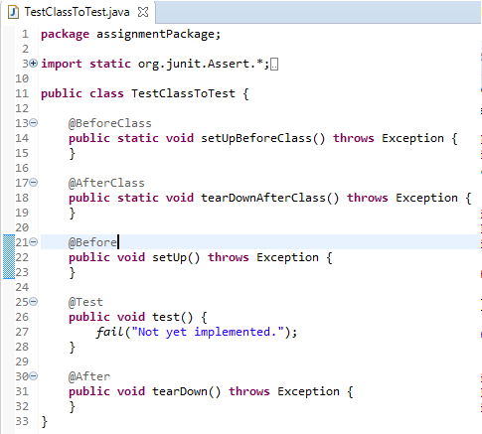

4.1.2 Code developed for the program.

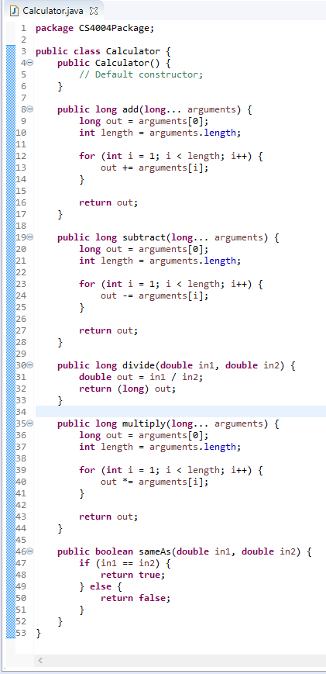

4.1.3 Screenshot of failure.

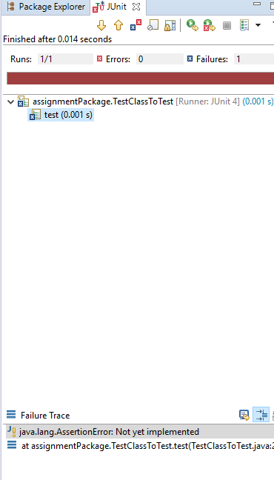

4.2 Test #2: Testing a Calculator class using test code developed by the group.

Code was added to test each of the methods until each of the test cases for each of the five methods were true. Code was added and changed in the program code to make the test cases valid in all scenarios.

4.1.1 Code developed for the test.

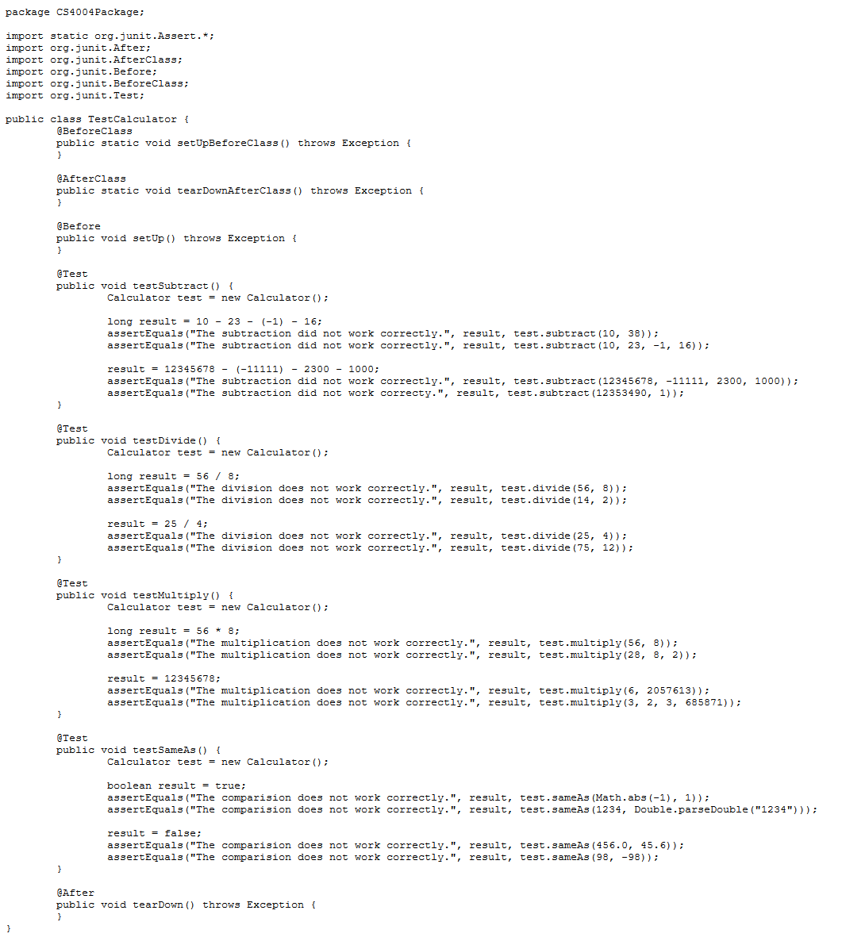

4.1.2 Code developed for the program.



4.1.3 Screenshots of success and failure.

**Failure**

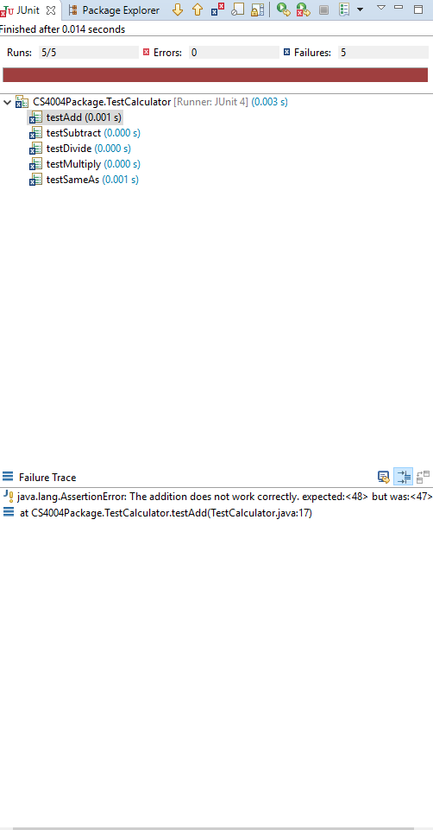

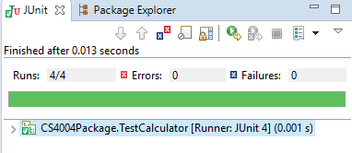

**Success**